Speaical Th

*Special Thanks too:*

Associated Student Organization

Black History Month Committee

LAMC Drama Club

LAMC Music Club

LAMC Music Department

Lakeview Terrace American

Baptist Church

Golden Voices Gospel Choir

LAMC Staff, Faculty, Students and Administrators

Education is our passport to the future, for tomorrow belongs to the people who prepare for it today.–

[Malcolm X](http://babyandblog.com/goto/https:/www.goodreads.com/author/show/17435.Malcolm_X)

To all the unsung heroes that fight the daily

struggles of oppression.

Wednesday, February 28, 2018

Culinary Arts Institute-(CAI) Student Dining 5pm-7pm.



**BLACK CULTURE LIVE**

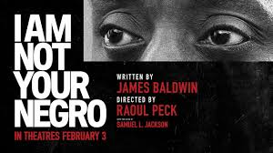

**Images**

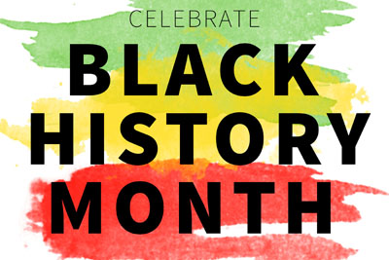

**Event Schedule**

* Introduction
* History of Black History Month
* Prayer-Deacon David W. Johnson
* Golden Voices Gospel Choir- LVT American Baptist Church
* Music Selection-Jazz Performance
* Play Excerpt
* Golden Voices
* Music Selection -Jazz Performance
* Spoken Word
* Closing